Experiment No: 1
Course Outcome: Blooms Level:
Aim: Case study on AI applications published in IEEE/ACM/Springer or any prominent journal or on any topic from the given list.

Abstract: The case study analysis requires you to conduct a comprehensive investigation of a real-world business problem or challenge faced by an organization. This involves identifying the root causes of the issue and gathering relevant data or evidence. Once the problem is clearly defined, the analysis must explore a range of alternative solutions, evaluating each based on factors such as feasibility, cost-effectiveness, potential risks, and long-term sustainability. The most effective solution should be selected and justified with strong supporting evidence, including theoretical frameworks, industry benchmarks, and practical examples. The goal is to develop a well-reasoned solution to the problem and adds measurable value to the organization.

Sample Topics:

Topic 1: The Blue Brain project

Topic 2: Spam Filter

Topic 3: Alphago(Google)

Theory:

Preparing the Case: Before you begin writing, follow these guidelines to help you prepare

and understand the case study

1. Read and examine the case thoroughly

Take notes, highlight relevant facts, underline key problems.

2. Focus your analysis

Identify two to five key problems

Why do they exist?

How do they impact the organization?

Who is responsible for them?

3. Uncover possible solutions

Review course readings, discussions, outside research, your experience.

4. Select the best solution

Consider strong supporting evidence, pros, and cons: is this solution realistic?

Drafting the Case: Once you have gathered the necessary information, a draft of your

analysis should include these sections

1. Introduction

Identify the key problems and issues in the case study. Formulate and include

a thesis statement, summarizing the outcome of your analysis in 1–2

sentences

2. Background

Set the scene: background information, relevant facts, and the most important

issues.

Demonstrate that you have researched the problems in this case study.

3. Alternatives

Outline possible alternatives

Explain why alternatives were rejected

4. Proposed Solution

Provide one specific and realistic solution

Explain why this solution was chosen

Support this solution with solid evidence

Concepts from class (text readings, discussions, lectures)

Outside research

Personal experience (anecdotes)

5. Recommendations

Determine and discuss specific strategies for accomplishing the proposed

solution. If applicable, recommend further action to resolve some of the

issues. What should be done and who should do it?

Finalizing the Case:

After you have composed the first draft of your case study analysis, read through it to

check for any gaps or inconsistencies in content or structure: Is your thesis statement

clear and direct? Have you provided solid evidence? Is any component from the

analysis missing? When you make the necessary revisions, proofread and edit your

analysis before submitting the final draft.

Output:

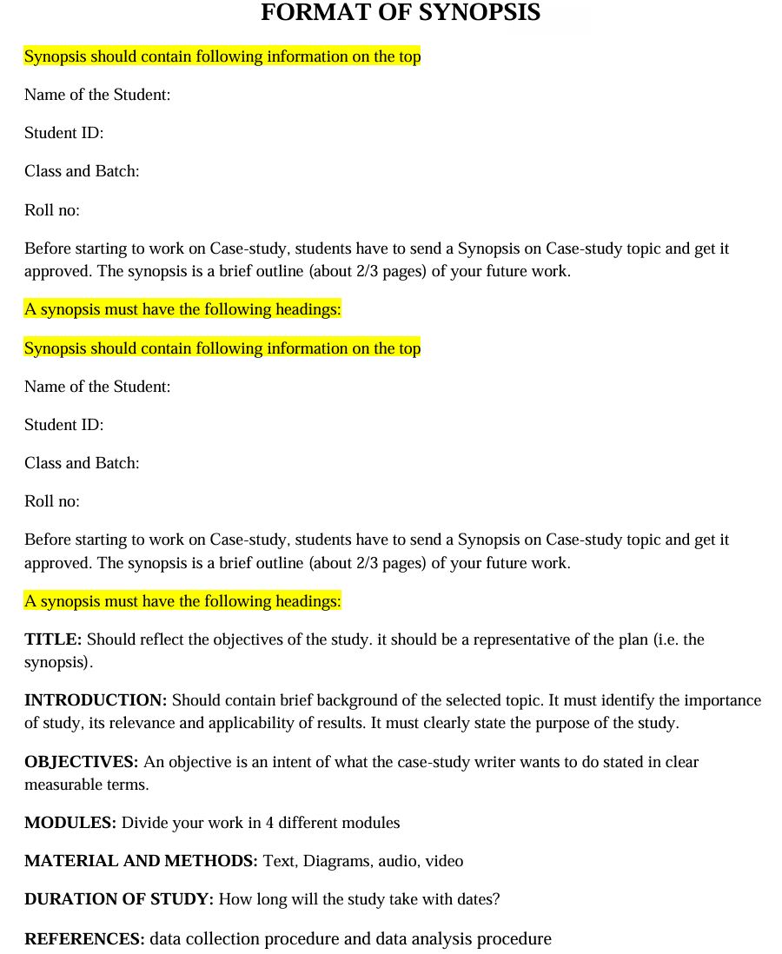

Conclusion:
Summarize the key findings and contributions of the case study. Reflect on the overall success and impact of the ML application or the proposed solution. Highlight any future enhancements or areas for further research.

Format of Case Study Report





